# Rebels - A Tactical Guide

Welcome to the Rebellion! The Rebel faction of Star Wars Legion is one of the most (if not the most) diverse factions in Star Wars: Legion. Now while we have a lot of ways to play, the Rebels are unified with a very similar strategy: guerrilla warfare. What I mean by this, is the implementation of hit and run tactics during actual gameplay. The main reasoning behind this being the Rebels’ high-powered offense combined with their inferior defensive capabilities.

With a few exceptions, Rebels roll white defense dice (which arguably are the worst in the game). Translated in gameplay, this usually means that in a straight-up fire fight, your initial shot better count or else you’re going to lose 9 times out of 10, as your army “melts” before your eyes. Therefore, it’s important as a Rebel player to always ‘stay on target’ and always play the objective. So what does it take for a Rebel to succeed? Improvisation! While we may not have superior armor, that lack of additional weight makes the standard Rebel troopers nimble (😉); additionally, what we lack in natural defenses we make up for with our danger sensibility and uncanny luck (😉😉). What I’m hinting at here are the amazing keywords that the Rebel faction has at its disposal to improve their survivability due to the lack of innate durability.

Now, while the Rebel factions natural defense may be low, our offensive capability is very high as we typically have superior dice quality and an abundance of the **Pierce** keyword. This type of faction skew is often referred to as a “glass cannon”, something that hits hard but can just as easily shatter into a million pieces if you’re not careful. Therefore, as a Rebel you need to look for key openings and take them when you can assure that you won’t take much fire in return. While this may sound simple to do, in actual gameplay it is a constant struggle to create these openings and capitalize on them. One way to create these openings is through a method called ‘flanking’ or ‘harrassing’, in which you deal little pieces of ‘chip’ damage in your opponents forces until the opening creates itself and you can then expose that weakness. Referring to the hit-and-run concept, the most common way to do this is to move in and out of cover repeatedly as you take your shots. It’s also for this reason that some people often refer to the Rebel faction as “mobile” even though the main units have the same speed as other factions.

After briefly gone over the Rebel faction as a whole, let’s look at some specific Commander options from the Rebel faction to highlight these key observations. Please note that I have added in some edits to reflect the recent points changes, errata, and some clarification for newer players:

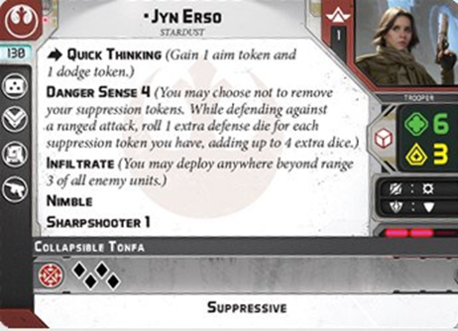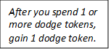

*“I’ll be there for you… Cassian said I had to.”*

*-K2-SO, Rogue One: A Star Wars Story*

Looking to quickly grab that objective and hold it? Look no further. After several points decreases (she was originally 130!) Jyn has become one of my favorites. She is a solid all-around commander that can hold her own while also supporting those around her. I have found that Jyn works best in the mid-field during play; you want her close enough to the action that she can help where needed, but I wouldn’t consider her a frontline brawler like Luke Skywalker or Freedom Fighter Wookiees.

So how does she fit in the Rebel survivable category? As hinted to before it mainly comes down to her two defensive keywords: **Danger Sense** and **Nimble**. While both seem straightforward, these keywords can have some timing-trickery associated with them. **Danger Sense** allows you to roll an extra defense die for each suppression token you have up to a certain value (in Jyn’s case: 4). Extra defense dice? Sweet! But here’s the catch: how do you get suppression tokens? Typically, you have to get shot at. There are however ways to get suppression without taking a potential bullet to the face, one of which being the upgrade: Duck and Cover. While you still have to get shot at to have this card trigger, getting the extra die before it’s too late is good in the right hands. Just make sure you manage your suppression (i.e. don’t get shot too many times, don’t always use Duck and Cover if you already have suppression tokens, etc.) and your white saves begin to look better than red saves ever did.

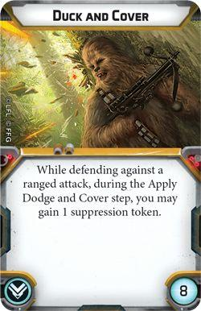

2

Next up: **Nimble**, on a basic level: once you have a dodge token, you always have a dodge token. This keyword is bread-and-butter to a lot of Rebel units and is really good… and only continues to get better. Before, when talking about **Danger Sense** we were talking about how to improve you chances of ‘saving out’ when you get shot at, but what if you could just negate the shots coming in before you even had to roll dice? I’d take that ALL. DAY. LONG. **Nimble** allows you to do just that as you regenerate one dodge token after you spend one or more dodge tokens. However, we run into a similar issue as before with **Danger Sense** which is that we need to get that token out before we get shot. Dodging before the shot happens requires going before your opponent, which isn’t always a luxury we have, so set it up beforehand! This brings in one of the best command slot upgrades in the game for Rebels: Vigilance. All this card takes to work is to have a dodge token on the unit you want to keep their token into the next round, in combination with **Nimble** this card perpetually creates a ‘permanent-dodge’ scenario. So, think ahead, decide who needs to hunker down for the next turn and hold that objective!

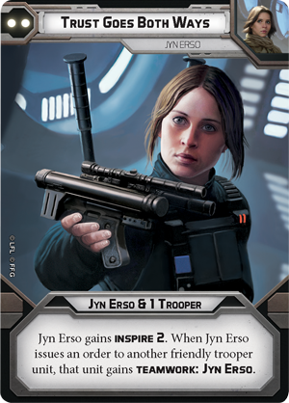 When playing as a Rebel player, your main goal should always be “play the objective” and speaking of objective play, one of my favorites with Jyn Erso is utilizes her 2-pip command card: ‘Trust Goes Both Ways’. This card is Jyn’s way of becoming the unmovable force that screams “NO! YOU MOVE!”. Playing this card mid to late game can ensure that you hold down the fort for a turn and that she (and whoever is issued an order) are not going to give up that objective easily. So how do you set this up? 3 ingredients: Jyn Erso, another unit with Nimble (Mandolorians are definitely the best pick here), and a dodge token. Utilizing Vigilance, set up a dodge token on whoever you think is in the most danger (likely to get shot at first the next round). Then during the turn that you play ‘Trust Goes Both Ways’ you can just sit back and let **Nimble + Teamwork** do the rest. **Teamwork: Jyn Erso** allows the other unit that was issued orders to gain a dodge or an aim token whenever Jyn gains an aim or dodge token (and visa versa). Therefore, when the unit that has the original dodge token gets shot and spends the dodge token, **Nimble** kicks in and the unit gains a dodge token back… but so does the other unit with **Teamwork** (😉). At this point your opponent has three options: give up and ignore those 2 units, double-down on shooting the first unit and allow the other to gain an absurd amount of dodge tokens, or play a nasty game of ‘ping-pong’ that forces one of the units to consistently have 2 dodge tokens. In any scenario, your opponent is going to feel frustrated as they struggle (and likely fail) to move you off that critical objective. Overall, Jyn is a fabulous commander to take if you need someone to capitalize on objective play while maintaining an “all-around” profile.

*“Why, you stuck-up, half-witted, scruffy-looking nerf herder!”*

*-Leia Organa, The Empire Strikes Back*

Oh Han, how I’ve missed you. Up until recently this lovable scoundrel has been very tough to justify having on the gameboard. At 100 points, Han is standard for an offensive-type commander in the Rebel faction. Prior to his errata however, for those same 100 points Cassian and Lando were just flat-out better bang-for-the-buck. Since the errata to **Low Profile** and the addition of the **Steady** keyword, Han is now starting to take back the table with his amazing firepower and command card trickery. With **Sharpshooter 1**, **Pierce 2**, and surge to *crit* in the dice pool, Han is usually scooping up a few models each turn that he gets to fire; this is sure to create that opening in your opponent’s forces that you look for as a Rebel player. Additionally, like Jyn, Han is usually best played in the mid-field where he is close enough to the action to utilize his offensive power, but isn’t usually associated with being a front-line brawler.

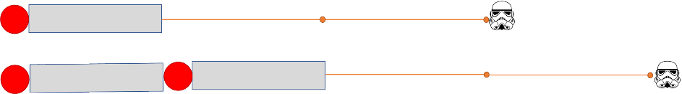 When it comes to ‘harrassing’, no one is doing it better than Han Solo as darting in and out of cover has never been easier with the addition of the **Steady** keyword. This allows Han to perform a “peek-a-boo” routine when utilizing a line-of-sight (LOS) blocker, since he can effectively move out, shoot twice using **Gunslinger** and **Steady**, then still have that last action to duck behind cover again. Since the addition of **Steady**, Han can stretch the field as he moves twice and still gets to shoot, effectively increasing his ‘threat-range’ by just under 6 inches. While this graphic representation is crudely made, it emphasizes the power of the addition of this one keyword to Han’s repertoire. Therefore, adding a movement-based upgrade card to his gear-slot (environmental gear, recon intel, or ascension cables) keeps Han very mobile during each game that he’s on the field.

Han Old Threat Range (top) v. New Threat Range (bottom)

However, the offensive capabilities of Han Solo are not the only thing that make him appealing, as he is very durable despite what those white defense dice suggest. There are not many opportunities to reroll or add defense dice in Star Wars: Legion; therefore, **Uncanny Luck** is amazing when it comes to the natural durability of a unit as the reroll of a single white defense die increases the likelihood of ‘saving out’ from 33% to 55% (that’s better than red saves)! However, this shouldn’t make you want to dive Han into enemy lines, instead you should see this as an opportunity for Han to really shine when it comes to objective play and enemy harassment. Additionally, as stated before with **Nimble**, if you can avoid having to roll dice all-together you should heavily consider that option. That’s where **Low Profile** comes in to play. Before the errata, **Low Profile** was honestly kind of a joke keyword that really didn’t add much value to a unit as any **Sharpshooter** basically negated its benefit. Now, while **Sharpshooter** 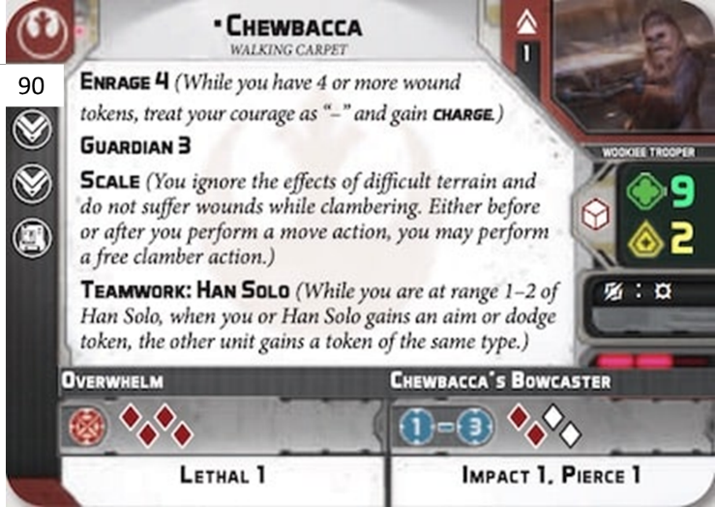can still mess with this keyword (if the **Sharpshooter** value is equal or greater than your cover type, **Low Profile** doesn’t work), the abundance of **Sharpshooter 1** is no longer a complete washout to units with **Low Profile**. Cover is critical in Legion and getting the added bonus of removing an extra *hit* from a dice pool has a similar feel to it as a permanent dodge token. Now add a dodge token to a unit with **Low Profile** behind heavy cover and that unit is likely not going to move off their objective (with the exception of panicking, of course). Additionally, where Han is involved, likely is furry companion: Chewbacca. Chewie helps improve Han’s natural survivability through the use of the **Guardian** keyword as well as **Teamwork** (which we dove deep into this keywords implications with Jyn Erso).

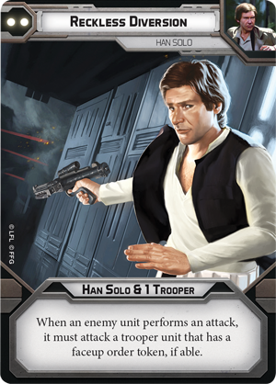 Finally, let’s round out this first tactical dive into Rebels by looking at a potential objective play with our beloved outlaw. As mentioned before, Han has amazing command cards and often one that is overlooked due to its vague implications is ‘Reckless Diversion’. This card has the potential to put Han in harms way for the greater good or to allow Han to slip through your enemy’s grasp. While this can be a situational card, ‘Reckless Diversion’ has an effect that could win the entire game for you as you get to dictate what is and isn’t shot at during a specific turn. Let’s set up the scenario, you’re playing the objective Recover the Supplies and you have a squad that needs to move away from the enemy as fast as possible with a critical objective, but they’re going to be just shy from safety. Meanwhile, Han is in a position behind cover, while being in LOS and range of enemy units that are looking to gun-down that objective carrier before they escape. Issue your orders to Han and the objective squad (pray for priority or set this up with ‘Change of Plans’) and then activate the objective carrier first and flip their token face down. Your opponent will then try to shoot at the carrier, but you get to politely remind them that the bunkered down Han (with **Low Profile** and **Uncanny Luck**) is the only valid target currently this round since he is the only character with a face-up order token.

[*“Congratulations! You are being rescued… Please do not resist.” -K2-SO, Rogue One: A Star Wars Story*] Likewise, if you realize that Han is currently in a bad position to get shot at by multiple hostiles, choose to go with Han first and leave the other sacrificial lamb to take the bullet instead. With either scenario, dictating the flow of battle gives you a leg up in the game and can be the deciding factor on who is victorious and who is not.

I sincerely hope that this little guide has given you a little insight on the way that I view Rebels and their tactical ingenuity. If you are new to Legion, the process of trial and error may end up feeling a bit like the velociraptors in Jurassic Park as you “test the fences”, but as you get more exposure and more confidence, you’ll soon begin to see the small weaknesses in your opponent’s game even as early as deployment or unit-choice and be able to capitalize on it. To get you started I have some sample lists that include the units that I mentioned in this article and hope you find some inspiration to try out during your next game

-May the Force be with you and remember that Rebellions are built on hope. Dylan K.

-This list is adapted from a Rogue One list that I have. Instead of Cassian and K2, it utilizes Han and Chewie. While there isn’t a true “hammer” in this list like you see in list with Luke and Wookiees, this list is designed to harrass your enemy to the point of frustration. Tauns, Han, and Chewie all get to pester the enemy while Jyn, the corps, and commandos all secure the objectives. To get Han and Chewie up into position quicker, you may decide to swap out the ‘Seize the Initiative’ on Jyn for Situtational Awareness on her, while giving Han and Chewie ‘Recon Intel’-

-Oh boy. Who called for the order of dodge tokens? I’ve run this list a few times in the past with great success. Mandos do not understand what chip damage is when they have a permanent dodge token, Outmaneuver, and Impervious. This list is fabulous at holding a center objective late in the game if you’re cautious in the early rounds. Also, never forget what Sabine can do to a gunline… Explosions can absolutely put your enemy’s corps into a head-lock. Just watch out for High-Velocity with this list.-

-The flavor of this list is my favorite, but it also has some serious ‘kick-assery’ as well. Run the Wookiees straight at the enemy or center objective with Han and Chewie in tow. The frontline durability of these three units is pretty spectacular. Additionally, utilizing Lando’s contingencies will make your opponent scream when you utilize Han and Chewie’s cards. One example is your ‘Change of Plans’ turn: Oops! Guessed wrong? Don’t actually want to play it this turn? Discard ‘Change of Plans’, contingency for Chewie’s 3 pip ‘Notorious Scoundrels’, immediately bring ‘Change of Plans’ into your hand for next turn (check out the timing, it works 😉).-